**Series, Parallel, Δ and Y Resistor Network**

**Lab 6**

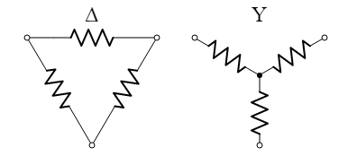

ECE 1101 Lab, Section 6

Date: Thursday, October 3rd, 2019

Kyler Martinez, Daniel Tan

Equipment Used In The Experiment:

* Keysight Triple Output DC Power Supply
  + Make/Model: E3630A
  + Serial Number: MY56186189
* Keysight 4 ½ Digital Display Multimeter
  + Make/Model: U3401A
  + Serial Number: MY56150032

Materials Used In The Experiment:

* Breadboard
* 2 1kΩ Resistor
* 3 3.3kΩ Resistor
* 3 6.8kΩ Resistor

Objective:

Students will create a circuit with eight resistors. A voltage will be applied to the circuit and students will measure the currents and voltages. The results will be compared to the calculations using theory as well as a simulation in PSPICE.

Background Theory:

The background theory used in the lab is that circuits that resemble a delta structure can be simplified into parallel and series resistors and vice versa. This can also be combined with mesh and nodal analysis to make solving a circuit easier.

Procedure:

In the lab, we had to build the circuit shown in figure 1 in our breadboard and then measure the mesh currents by finding the current through the power supply, the resistor between V1 and V2, the resistor between V2 and V4, and finally the resistor between V4 and ground. We are then to find the node voltages by measuring the voltage drop from the node to ground. After that, we are to calculate the currents and node voltages by using node and mesh analysis.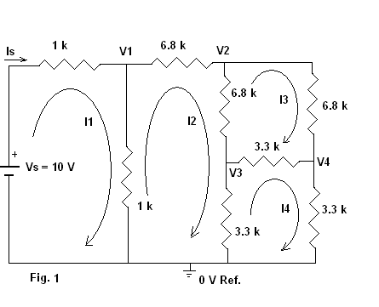

For the second half of the lab, we are to calculate the equivalent resistance with the voltage source and current through the voltage source and then use Series, Parallel, Δ, and Y Resistor conversions to calculate the equivalent resistance and then compare the results.

Data:

Resistor Measurements

|  |  |  |  |  |  |  |  |  |
| --- | --- | --- | --- | --- | --- | --- | --- | --- |
| Plate Value | R1=1kΩ | R2=1kΩ | R3=3.3kΩ | R4=3.3kΩ | R5=3.3kΩ | R6=6.8kΩ | R7=6.8kΩ | R8=6.8kΩ |
| Measured Value | .995 kΩ | .9938 kΩ | 3.2801kΩ | 3.2803kΩ | 3.282kΩ | 6.747kΩ | 6.772kΩ | 6.741kΩ |

Mesh Equations

i1(R1+R2) - i2(R2)=10

i2(R2+R6+R7+R4) - i3(R7)- i4(R4)- i1(R4)=0

i3(R8+R7+R3) - i4(R3)- i2(R7)=0

i4(R3+R4+R5) - i2(R4)- i3(R3)=0

Nodal Equations

(V1)/R2 + (V1-V2)/(R6) + (V1-10)/R1 = 0

(V2-V1)/R6 + (V2-V3)/(R7) + (V2-V4)/R8 = 0

(V3-V2)/R7 + (V3)/(R4) + (V3-V4)/R3 = 0

(V4)/R5 + (V4-V3)/(R3) + (V4-V2)/R8 = 0

Measurements

|  |  |  |  |  |  |  |  |  |
| --- | --- | --- | --- | --- | --- | --- | --- | --- |
|  | I1 | I2 | I3 | I4 | V1 | V2 | V3 | V4 |
| Measured | 4.9759 mA | .4047 mA | .2027 mA | .2015 mA | 4.7995 V | 2.0475 V | .6692 V | .6698 V |
| Calculated | 5.232 mA | .4075 mA | .2041 mA | .2038 mA | 4.794 V | 2.045 V | .668 V | .669 V |
| Simulation | 5.232 mA | .4075 mA | .2041 mA | .2038 mA | 4.794 V | 2.045 V | .668 V | .669 V |
| Discrepancy | 3.675 % | .6945 % | .7104 % | 1.1335 % | .115 % | .122 % | .1796 % | .1196 % |

|  |  |  |  |
| --- | --- | --- | --- |
|  | Vs | Is | RT |
| Measured | 10 V | 4.9785 mA | 2.0086 kΩ |
| Calculated | 10 V | 5.232 mA | 1.9114 kΩ |
| Simulation | 10 V | 5.232 mA | 1.9114 kΩ |
| Discrepancy | N/A | 4.845 % | 5.085 % |

**PSPICE Simulation**

Simulation results using plate values

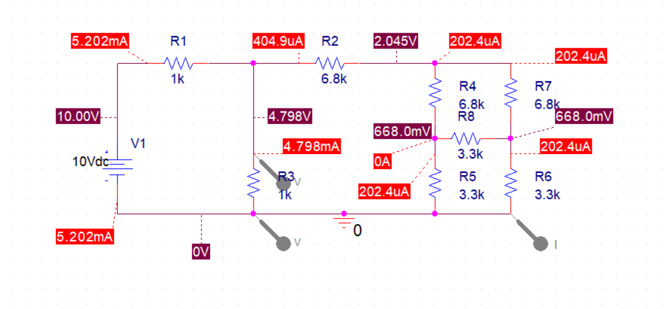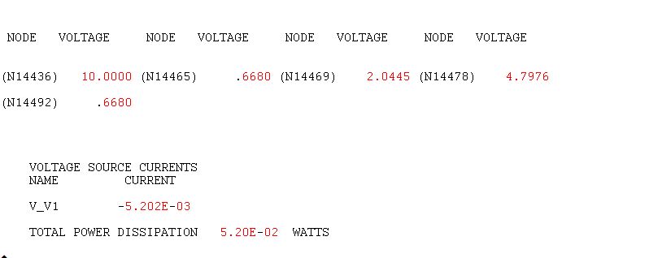

Simulation results using measured values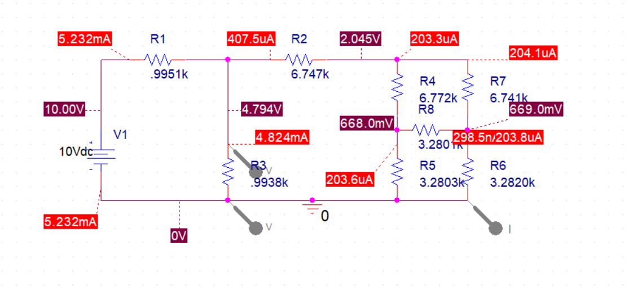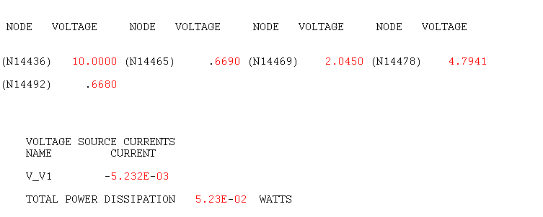

Conclusion:

Our measured data showcases that the delta wye transformation does work due to having relatively small percent errors when compared to our simulated and calculated data. Our percent errors where all below 5.1% with an average of 1.84% Our percent errors can be attributed to resistors potentially coming into contact with each other and there could have been energy lost through our wires if they are getting old and wearing down.